St Gregory’s Catholic Primary School
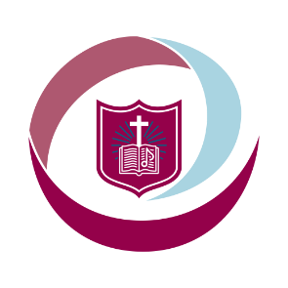
‘Loving and Learning’
The St Gregory’s Curriculum

Art and Design

“But now, O Lord, you are our Father; we are the clay, and you are our potter; we are all the work of your hand.”
Isaiah 64:8

Catholic Social Teaching
Human Dignity. Participation
Catholic School Pupil Profile
Curious. Discerning.

Curriculum Intent for Art and Design
At St Gregory's we aim to provide all children with a high-quality art curriculum, which develops creativity, sets challenges, engages and inspires children.
We aim to prepare our pupils with the knowledge and appropriate skills to experiment, invent and create their own works of art, craft and design, as well as enjoying what they are setting out to do.
We aim to develop the confidence of our children, to apply skills gained across a range of topics, and strive to continuously improve.
We believe that art is an essential part of the school curriculum, which allows children to be creative and explore their own ideas. This is reflected across the whole school in our creative curriculum.

Curriculum Implementation for Art and Design
To ensure high standards of teaching and learning in art and design, we implement a curriculum that is progressive throughout the whole school. Art and design is taught using the Kapow scheme of work, focusing on knowledge and skills stated in the National Curriculum.
Teachers plan lessons for their class using Kapow and our progression of knowledge and skills documents. The progression document ensures the curriculum is covered and the skills/knowledge taught is progressive from year group to year group.

Curriculum Impact for Art and Design
Teachers use sketchbooks to evidence the children's work. These are a working document, which should be individual to the child. Pupils are given opportunities to evaluate their work and teachers encourage the children to explore their own ideas, thoughts and opinions through the development of their sketchbooks.
Teachers assess the children through the development of their sketchbooks and their final piece of work for each unit. They will make continuing assessments throughout their art journey over the half term through photos and short written observations. The children will receive an appropriate result at the end of each half term and this is recorded on the school database where the data is collated.

